Infosys Springboard virtual internship 6.0
Project: Tempest – Fire Weather Index (FWI) Predictor
Student Name: Devinandhana M S
Date:08-12-25
1.Abstract
The Tempest FWI Predictor is a machine learning model that estimates the Fire Weather Index, FWI, using environmental features such as temperature, humidity, wind speed, rainfall, and FWI sub-indices: FFMC, DMC, and ISI. The purpose of the project is to support Wildfire Early Detection Systems used by Forest Departments and Environmental Agencies. The model uses Supervised Learning Regression and is deployed through a Flask web application. This document covers the workflow of the project, including data collection, preprocessing, model training, evaluation, and deployment.

2.Objective
• Build an ML model to predict Fire Weather Index (FWI)
• Train Regression model using environmental features
• Build a Flask web app for real-time prediction
• Enable early wildfire detection and risk assessment
3.Dataset Description
Dataset Name: FWI_Dataset.csv
Sourse: kaggle
Rows: 245
Columns: 15
Features:
• Temperature – Celsius
• RH – Relative Humidity
• Ws – Wind Speed (km/h)
• Rain – mm
• FFMC – Fine Fuel Moisture Code
• DMC – Duff Moisture Code
• DC – Drought Code
• ISI – Initial Spread Index
• BUI – Buildup Index
• FWI – Target variable
• Classes – Fire intensity category
• Region – geographical area
df.head()
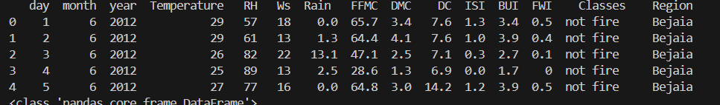

4.Module 1 — Data Collection & Exploration
data_processing.py
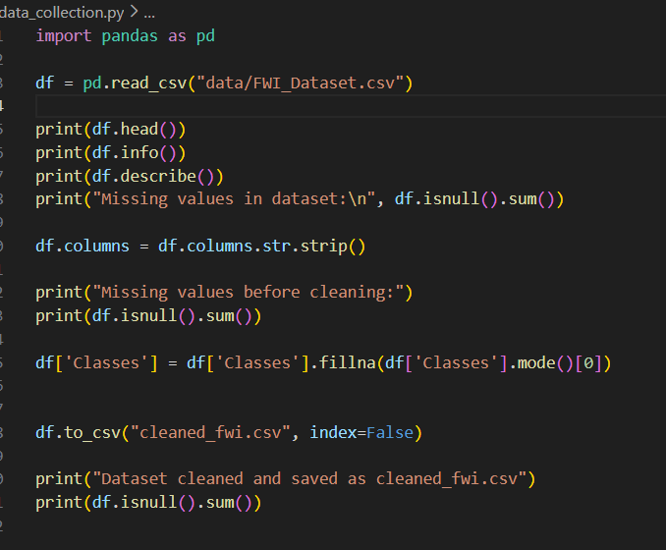
Output:
df.info()
df.describe()
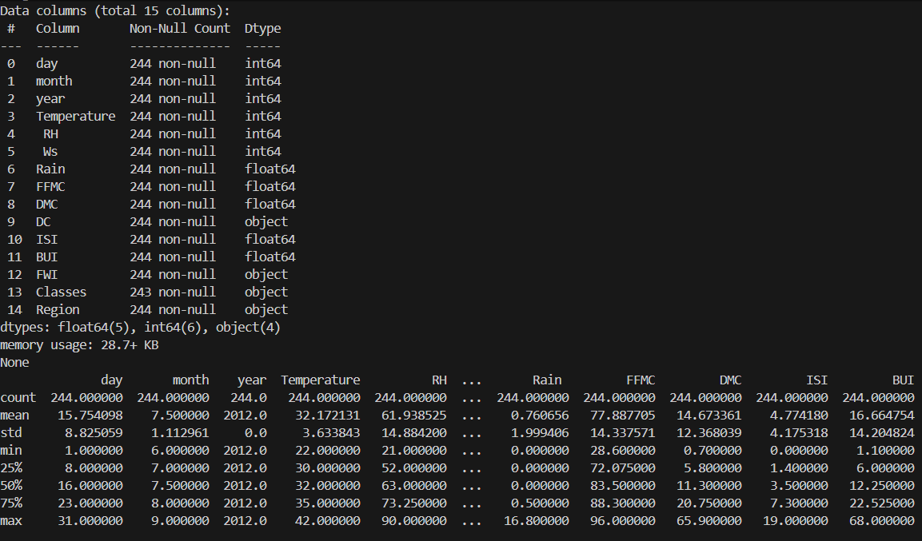
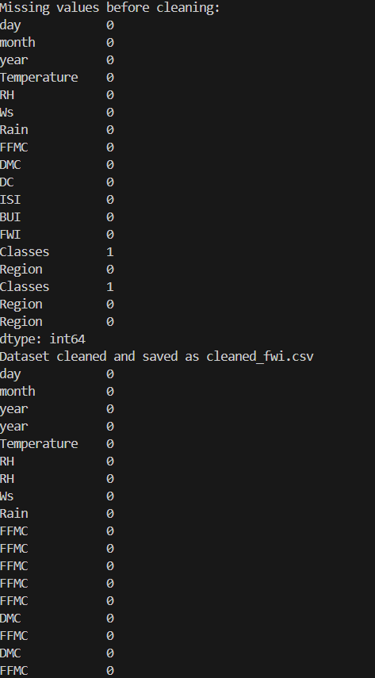
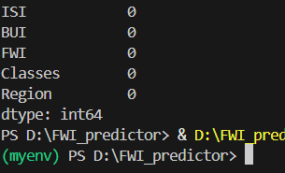

5. Module 2 — Data Preprocessing
Code:
import pandas as pd
import matplotlib.pyplot as plt
import seaborn as sns
from sklearn.preprocessing import LabelEncoder

df = pd.read_csv("data/cleaned_fwi.csv")

print("Dataset loaded successfully!\n")
print(df.head())
print("\nMissing values after cleaning:\n")
print(df.isnull().sum())

# histogram
df.hist(figsize=(12, 10))
plt.tight_layout()
plt.show()

# Boxplots for detecting outliers
plt.figure(figsize=(12, 8))
df.boxplot()
plt.xticks(rotation=45)
plt.show()

# Remove outliers using IQR method
numeric_cols = df.select_dtypes(include=['int64', 'float64']).columns

for col in numeric_cols:
Q1 = df[col].quantile(0.25)
Q3 = df[col].quantile(0.75)
IQR = Q3 - Q1
lower = Q1 - 1.5 * IQR
upper = Q3 + 1.5 * IQR
df = df[(df[col] >= lower) & (df[col] <= upper)]

print("\nAfter removing outliers, dataset shape:", df.shape)

if df['Region'].dtype == 'object':
le = LabelEncoder()
df['Region'] = le.fit_transform(df['Region'])

print("\nRegion column encoded successfully!")
print(df['Region'].head())

df.to_csv("data/cleaned_fwi.csv", index=False)
print("\nSaved: data/cleaned_fwi.csv")
Output:
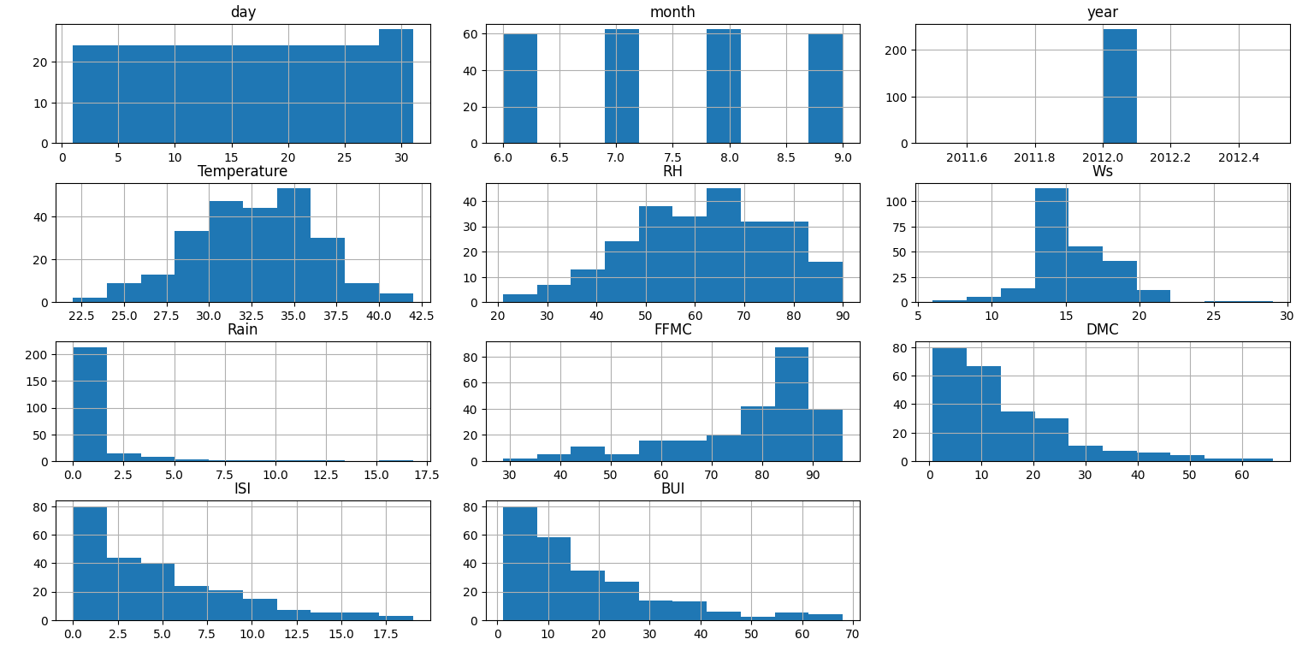

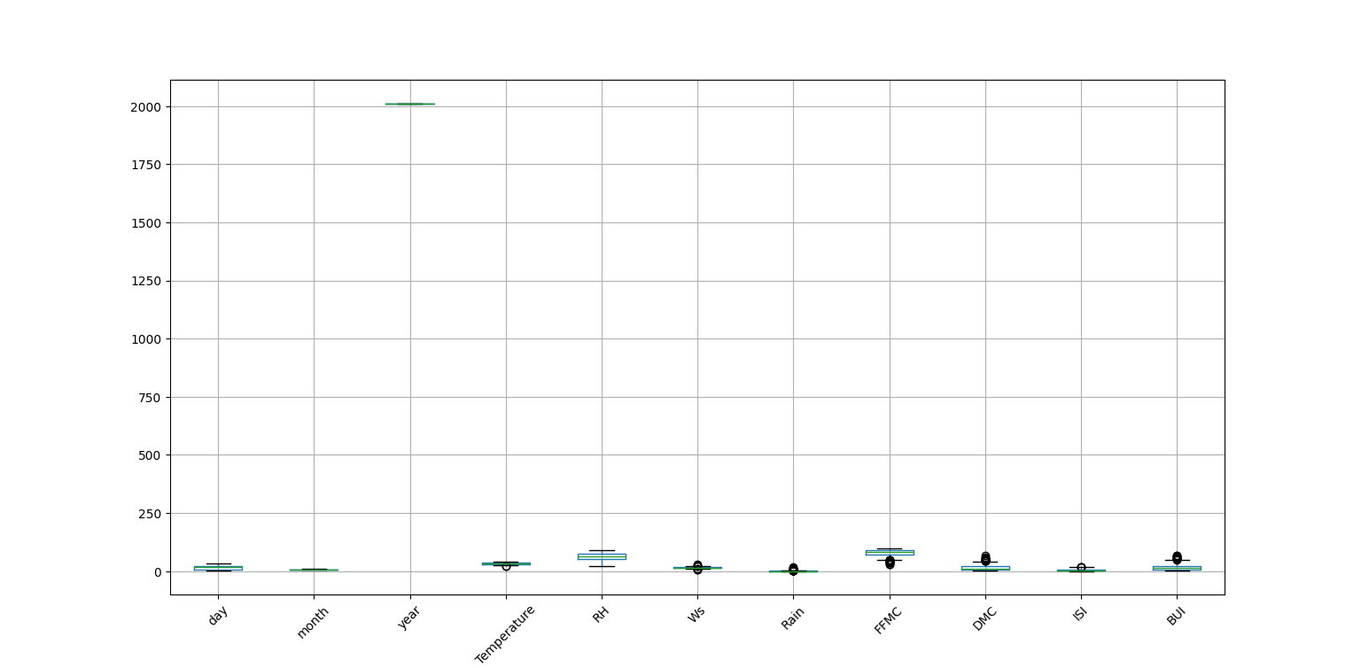

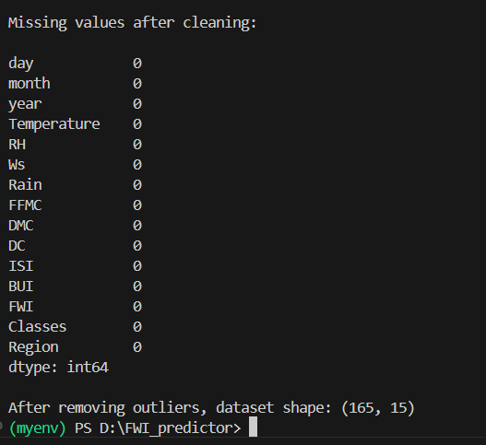

Region Enoding (categorical data is encoded)
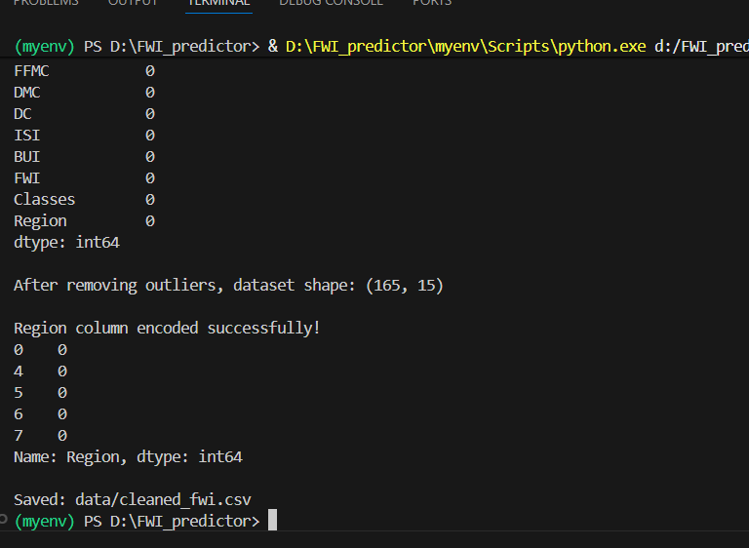
6.Module 3 — Feature Scaling

